

NATIONAL UNIVERSITY OF TECHNOLOGY ISLAMABAD
DEPARTMENT OF COMPUTER SCIENCE
DIGITAL LOGIC DESIGN LAB

Name | Bisma Fatima
Roll No | 36
Batch | 24
Section | A
Lab Number | 06
Instructor Name | Sir Haseeb  Miss Tehreem khalil
Date of Submission | April 07TH, 2025
Topic Covered | Implementing Adders and Subtractors

Experiment 6
Implementing Adders and Subtractors

Objective
- To experimentally verify the operation of basic adders and subtractors
- To design various configurations of adders and subtractors

Tools/Equipment Requirement
- ICs as required
- 7486 (XOR gate)
- 7408 (AND gate)
- 7404 (NOT gate)
- 7432 (OR gate)

- Digital Electronics trainer.

Theoretical Explanation
An adder is a digital circuit that performs addition of numbers. The half adder adds two binary digits called as augend and addend and produces two outputs as sum and carry; XOR is applied to both inputs to produce sum and AND gate is applied to both inputs to produce carry.
The half subtractor is a combinational circuit which is used to perform subtraction of two bits. It has two inputs, the minuend and subtrahend and two outputs the difference and borrow out.
A full adder is a logical circuit that performs an addition operation on three one-bit binary numbers. The full adder produces a sum of the three inputs and carry value.
The following experiment involves the design of adder/subtractor circuits using the formation of Boolean expression using truth tables.

Half Adder
- Complete the truth table.
- Write the logic equations for Sum and Carry.
- Draw the complete logic diagram for the Half Adder.
- Verify your results practically.

Observations/Truth Table
 | Truth Table |  |  | Practical Values
A | B | SUM | CARRY | SUM | CARRY
0 | 0 | 0 | 0 | 0 | 0
0 | 1 | 1 | 0 | 1 | 0
1 | 0 | 1 | 0 | 1 | 0
1 | 1 | 0 | 1 | 0 | 1

Equations
Sum = A ⊕ B Carry = A * B

Procedure
- Take two binary inputs, A and B.
- Calculate the sum (S) using XOR operation: S = A ⊕ B.
- Calculate the carry (C) using AND operation: C = A * B.

Circuit/Logic Diagram
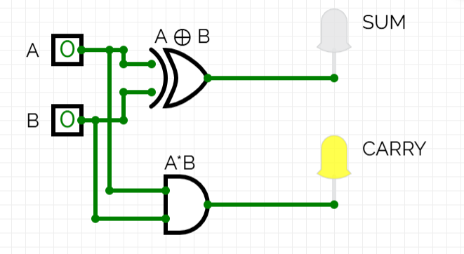
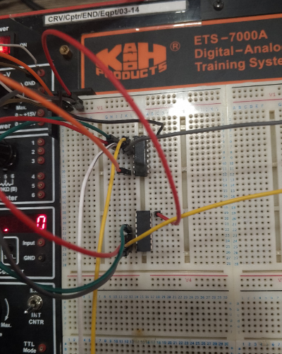
Explanation of circuit
In above figures we have used 2 IC chips [ XOR ,AND]. XOR chip is use to make the logical circuit of SUM And AND chip is use to make the logical circuit of CARRY. We have taken 2 inputs [A,B]. Also we shows two output wires , 1 show output for SUM and other shows output for CARRY.

Half Subtractor
- Complete the truth table.
- Write the logic equations for Difference and Borrow.
- Draw the complete logic diagram for the Half Subtractor.
- Verify your results practically.

Observations/Truth Table
 | Truth Table |  |  | Practical Values
A | B | Borrow | Difference | Borrow | Difference
0 | 0 | 0 | 0 | 0 | 0
0 | 1 | 1 | 1 | 1 | 1
1 | 0 | 0 | 1 | 0 | 1
1 | 1 | 0 | 0 | 0 | 0

D = A ⊕ B B = A’*B
Procedure
- Take two binary inputs, A and B.
- Calculate the difference using XOR operation: S = A ⊕ B.
- Calculate the borrow using AND,NOT operations: C = A’* B.
Circuit/Logic Diagram
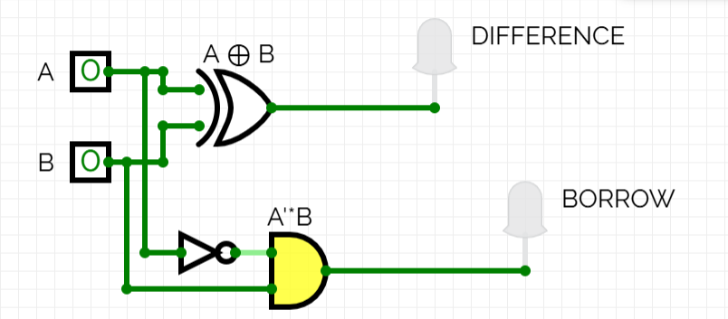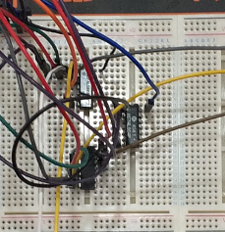
Explanation of circuits
In above figures we have used 3 IC chips [ XOR ,AND,NOT]. XOR chip is use to make the logical circuit of DIFFERRNCE And AND,NOT chips are use to make the logical circuit of BORROW. We have taken 2 inputs [A,B]. Also we shows two output wires , 1 show output for DIFFERENCE and other shows output for BORROW.
Full Adder
- Draw the complete logic diagram.
- Write the logic equations for Sum and Carry out.
- Complete the Truth Table.
- Implement the circuit on trainer.
- Verify your results practically.

Observations/Truth Table
 |  | Truth Table |  |  | Practical Values
A | B | Ci | SUM | C_{o} | SUM | C_{o}
0 | 0 | 0 | 0 | 0 | 0 | 0
0 | 0 | 1 | 1 | 0 | 1 | 0
0 | 1 | 0 | 1 | 0 | 1 | 0
0 | 1 | 1 | 0 | 1 | 0 | 1
1 | 0 | 0 | 1 | 0 | 1 | 0
1 | 0 | 1 | 0 | 1 | 0 | 1
1 | 1 | 0 | 0 | 1 | 0 | 1
1 | 1 | 1 | 1 | 1 | 1 | 1

Co = (A·B) + (B·Ci) + (A·Ci)
Full adder sum equation:
S = A’B’Ci + A’BCi’+AB’Ci’+ABCi
S=A’(B’Ci+BCi’)+A(B’Ci’+BCi)
S=A’(B ⊕ Ci )+A((B ⊕ Ci)’)
S=(A ⊕ B ) ⊕ C
Full adder carry equation:
Co=A’.B.Ci+A.B’.Ci+A.B.Ci’+A.B.Ci B.Ci
by using k-map we simplify it;
A\BCi | B’Ci’ | B’Ci | BCi | BCi’
A’ |  |  | 1
A |  | 1 | 1 | 1

A.Ci A.B
Co=A.B+A.Ci+B.Ci
Procedure
- Take three binary inputs: A, B, and Cin (carry-in).
- Calculate the sum (S) using XOR operation: S = A ⊕ B ⊕ Cin.
- Calculate the carry (Cout) using the following formula: Cout = (A * B) + (A * Cin) + (B * Cin).

Circuit/Logic Diagram
- Logical diagram for SUM
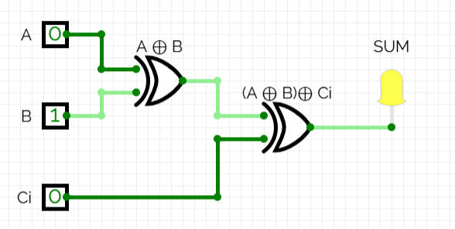
- Logical diagram for CARRY
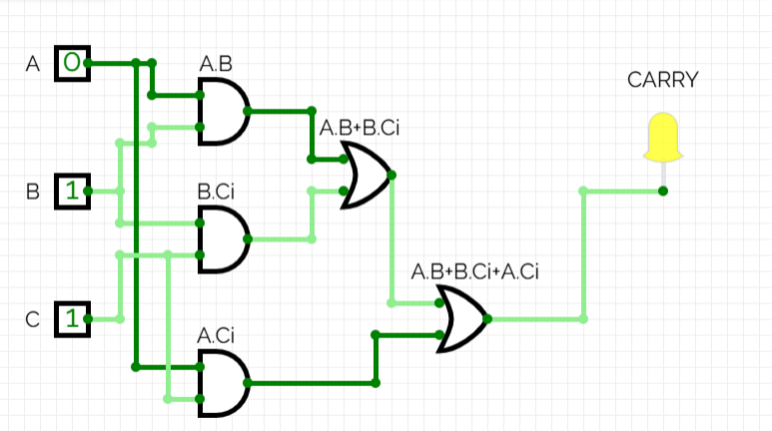

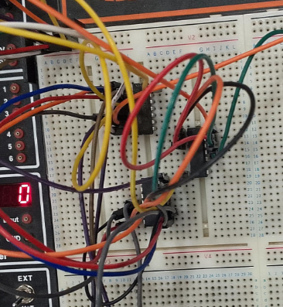
Explanation of circuit
In above figures we have used 3 IC chips [ XOR ,AND,OR]. XOR chip is use to make the logical circuit of SUM And AND,OR chips are use to make the logical circuit of CARRY. We have taken 3 inputs [A,B,Ci]. Also we shows two output wires , 1 show output for SUM and other shows output for CARRY.
Post Lab Task
- Design a 4-bit Ripple Carry Adder using Full Adders.
- Draw its Truth table and logic Diagram using CircuitVerse
Concept
A Ripple Carry Adder (RCA) is essentially a series of full adders connected in a sequence. In this setup, the carry-out from one bit is passed on as the carry-in to the next bit.
Structure
- It consists of four full adders.
- Input: Two 4-bit numbers, A[3:0] and B[3:0], along with an initial carry-in (C0).
- Output: A 4-bit Sum and the final carry-out (C4).

Observations/Truth Table
A3 | A2 | A1 | A0 | B3 | B2 | B1 | B0 | Cin | Sum3 | Sum2 | Sum1 | Sum0 | Cout
0 | 0 | 0 | 0 | 0 | 0 | 0 | 0 | 0 | 0 | 0 | 0 | 0 | 0
0 | 0 | 0 | 1 | 0 | 0 | 0 | 1 | 0 | 0 | 0 | 1 | 0 | 0
0 | 0 | 1 | 1 | 0 | 0 | 1 | 0 | 0 | 0 | 1 | 0 | 1 | 0
0 | 0 | 1 | 1 | 0 | 0 | 1 | 1 | 0 | 0 | 1 | 1 | 0 | 0
1 | 0 | 0 | 0 | 0 | 0 | 0 | 0 | 0 | 1 | 0 | 0 | 0 | 0
1 | 0 | 0 | 1 | 0 | 0 | 0 | 1 | 0 | 1 | 0 | 1 | 0 | 0
1 | 1 | 0 | 0 | 0 | 1 | 0 | 1 | 0 | 1 | 1 | 1 | 1 | 0
1 | 1 | 1 | 1 | 1 | 1 | 1 | 1 | 1 | 1 | 1 | 1 | 1 | 1

Equations:
Sum Bits
Sum3
- Sum3 = (A3 XOR B3) XOR Cin
Sum2
- Sum2 = (A2 XOR B2) XOR (Carry from Sum3)
Sum1
- Sum1 = (A1 XOR B1) XOR (Carry from Sum2)
Sum0
- Sum0 = (A0 XOR B0) XOR (Carry from Sum1)
Carry Out
Cout = (A3 AND B3) OR (Cin AND (A3 XOR B3)) OR (Carry from Sum3)
I've used the following notation:
XOR: ⊕
AND: ⋅ or AND
OR: + or OR
Explanation
4-Bit Binary Adder Explanation
- Inputs
  - A: 4-bit binary number (A3, A2, A1, A0)
  - B: 4-bit binary number (B3, B2, B1, B0)
  - Cin: Input carry
- Outputs
  - Sum: 4-bit sum (Sum3, Sum2, Sum1, Sum0)
  - Cout: Carry-out
- Operation
- The adder calculates the sum bit-by-bit, considering the carry from the previous bit. The carry-out indicates whether there's a carry-over from the most significant bit.
- Truth Table
- The table shows all possible input combinations and their corresponding sum and carry-out values.

Circuit/Logic Diagram
First Image – Full Adder Circuit
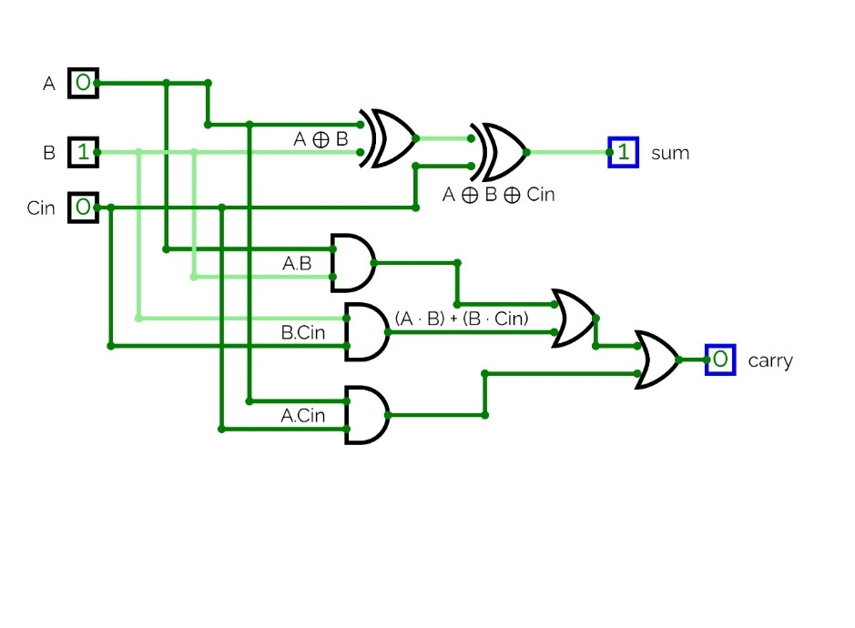

This full adder circuit diagram shows its internal operation:
- Inputs
- A
- B
- Cin (carry-in)
- Outputs
- Sum (result of A, B, and Cin addition)
- Carry (output carry)
- Logic Operations
- XOR gates calculate the sum (A ⊕ B ⊕ Cin)
- AND and OR gates compute the carry ((A AND B) OR (B AND Cin) OR (A AND Cin))
This diagram provides a detailed, logic-level view of a single-bit full adder's operation.

Second Image – 4-Bit Ripple Carry Adder
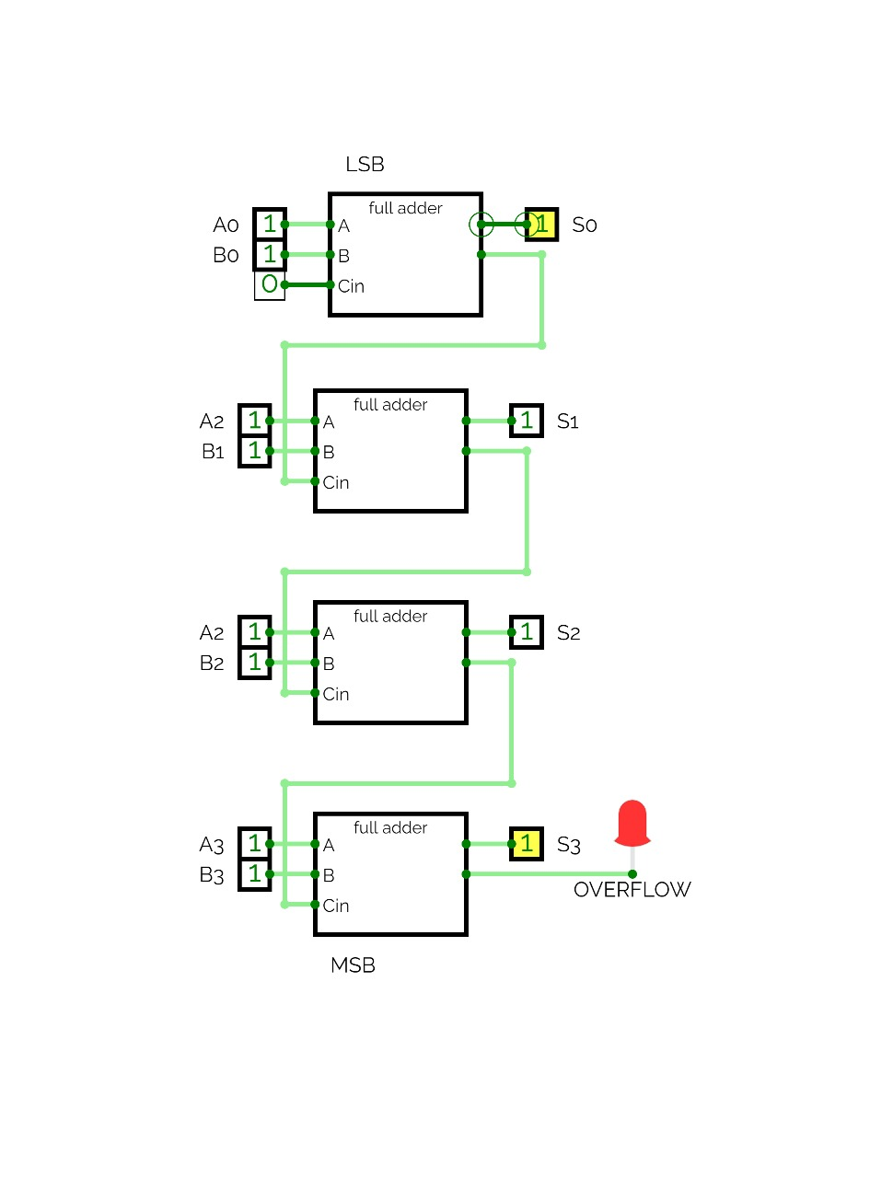
This circuit connects four full adders in a series:
How it works
- Each full adder processes one bit, starting from the least significant bit (LSB) and moving to the most significant bit (MSB).
- The carry output from each stage is passed on to the next stage.
- The final result includes a 4-bit sum (S0-S3) and an overflow indicator (shown by a red LED).
This setup is called a ripple-carry adder.
Learning Outcomes
- Experience with arithmetic logic circuits.
- Learned to apply truth tables to Boolean expressions.
- Created logic diagrams from Boolean expressions.
- Understood full adder structure in ripple-carry systems.
- Developed practical skills with digital trainer boards and integrated circuits.

